
OptiCrop :Smart Agricultural Production Optimization Engine
Project Description:
The Smart Agricultural Production Optimization Engine (OptiCrop) is an intelligent, Machine Learning-based web application designed to assist farmers in selecting the most suitable crop based on soil nutrients and environmental conditions. The system analyzes key agricultural parameters such as Nitrogen (N), Phosphorus (P), Potassium (K), temperature, humidity, soil pH, and rainfall to predict the crop that is most likely to produce higher yields under the given conditions.
Traditional farming methods often rely on experience and assumptions, which can lead to poor crop selection, low productivity, and inefficient use of resources. OptiCrop addresses this challenge by leveraging data-driven insights and predictive analytics to provide accurate crop recommendations. The application is built using Python, Flask, Scikit-learn, NumPy, Pandas, Matplotlib, Seaborn, HTML, CSS, and JavaScript, providing a simple and user-friendly interface for farmers and agricultural stakeholders.
Scenarios
Scenario 1: A user describes a new summer collection of sustainable sunglasses and selects Instagram with a Casual tone. The system generates three emoji-rich captions optimized for Instagram’s visual-first audience, ten relevant hashtags mixing broad and niche tags, and three punchy CTAs all in seconds.
Scenario 2: A user promoting a B2B SaaS product selects LinkedIn with a Professional tone. CaptionAI generates thought-leadership-style captions with a value-driven narrative, industry-relevant hashtags, and CTAs designed to drive professional engagement such as demo sign-ups or article reads.
Scenario 3: A user running a weekend flash sale selects Instagram with a Promotional tone. The AI generates urgency-driven captions filled with power words, a curated hashtag set targeting deal-seekers, and CTAs like “Shop before it’s gone!” to maximize conversion.

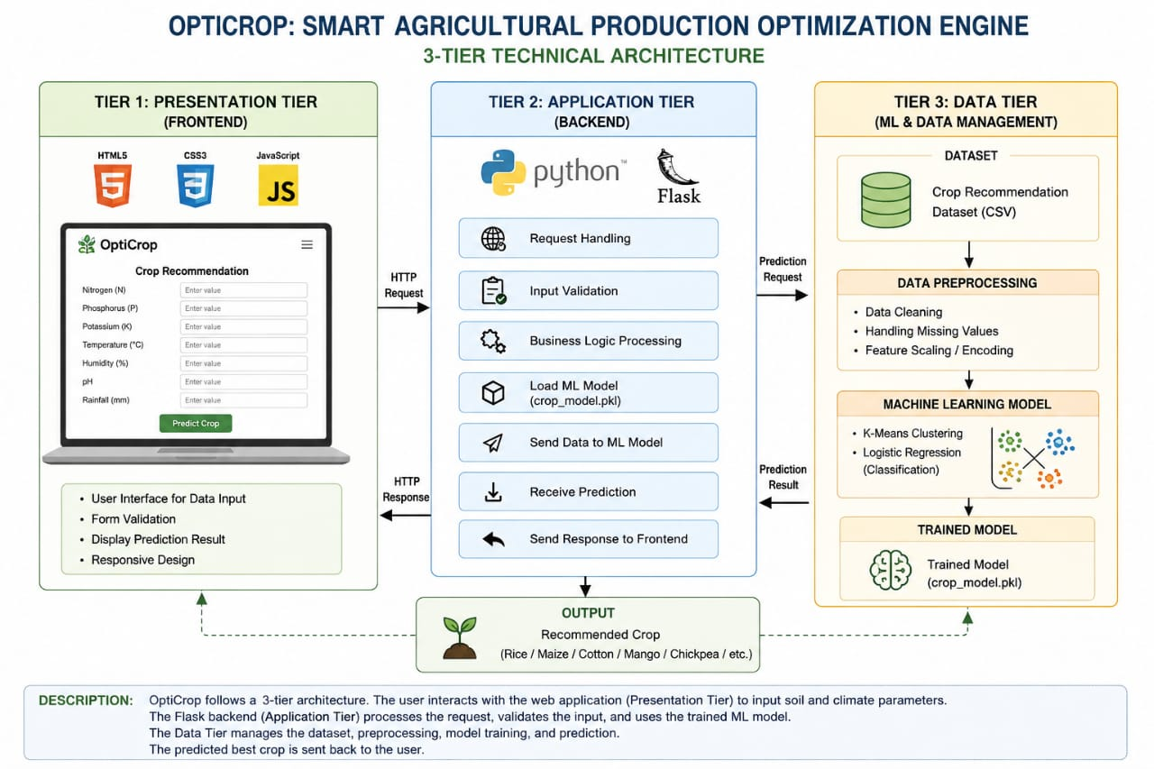
Description: The Smart Agricultural Production Optimization Engine (OptiCrop) follows a three-tier architecture consisting of the Presentation Layer, Application Layer, and Machine Learning Layer. The architecture enables efficient interaction between users and the crop recommendation system by integrating a web interface, Flask backend, and a trained Machine Learning model.
Pre-requisites:
● Flask Framework Knowledge: Flask Documentation
● HTML, CSS, and JavaScript Skills: W3Schools HTML/CSS/JavaScript Tutorials ● Python Programming Proficiency: Python Documentation
● Version Control with Git: Git Documentation
● Development Environment Setup: Flask Installation Guide
● Vscode for Public Deployment: Localhost(127.0.0.1)

Project Workflow:
Milestone 1: Problem Identification• Activity 1.1: Study crop production challenges.
Activity 1.2: Identify factors affecting crop yield.
• Activity 1.3: Define project objectives.

Milestone 2: Requirement Analysis
• Activity 2.1: collect functional requirements.
• Activity 2.2: collect non-functional requirements and decide input parameters(N,P,K,Temperature,Humidity,Soil pH,Rainfall).
Milestone 3: Dataset collection
• Activity 3.1: collect crop recommendation dataset.
• Activity 3.2: download Crop Recommendation Dataset and store data as CSV.
Milestone 4: Data preprocessing
• Activity 4.1: Prepare dataset for machine learning.
• Activity 4.2: remove missing values,check duplicate records,verify datatypes and split input and output.
Milestone 5: Model Development
• Activity 5.1: train the ML model.
• Activity 5.2: Train Random forest classifier,evaluate model accuracy and save trained model.

Milestone 6: Frontend Development
• Activity 6.1: design the user interface.
• Activity 6.2: create input forms,add labels and buttons with HTML ,improve UI using CSS.

Milestone 7: Backend integration
• Activity 7.1: connect frontend with ML model.
• Activity 7.2: Load trained model,Accept user inputs,predict crop,display recommendation.
Milestone 8: Testing and Deployment
• Activity 8.1: validate application performance,test input ,verify prediction and fix bugs to test the model.
• Activity 8.2: Make application ready for users in Vscode,run application locally,upload source code to github and prepare documentation.
Milestone 9: Conclusion



Dataset Description
The dataset consists of agricultural records collected from different farming conditions. Each record contains seven input features and one output label.

Input Features
Feature | Description
Nitrogen (N) | Amount of Nitrogen present in soil
Phosphorus (P) | Amount of Phosphorus present in soil
Potassium (K) | Amount of Potassium present in soil
Temperature | Atmospheric temperature (°C)
Humidity | Relative humidity (%)
Soil pH | Soil acidity/alkalinity level
Rainfall | Annual rainfall (mm)

Output
- Recommended Crop

Data Preprocessing
Before training the Machine Learning model, the dataset undergoes several preprocessing steps to improve prediction accuracy.

Step 1: Data Loading
The dataset is loaded using the Pandas library.
df = pd.read_csv("Crop_Recommendation.csv")

Step 2: Data Cleaning
- Checked for missing values
- Removed duplicate records
- Verified data consistency

Step 3: Feature Selection
Selected input variables:
- Nitrogen
- Phosphorus
- Potassium
- Temperature
- Humidity
- pH
- Rainfall
Output variable:
- Crop
Insert Figure 5.2: Dataset Preprocessing Flow
(Image: Raw Dataset → Cleaning → Feature Selection → Train-Test Split)

Feature Scaling
The dataset contains numerical values with different ranges. To ensure all features contribute equally during model training, StandardScaler is used.
The scaler transforms each feature into a standardized format with:
- Mean = 0
- Standard Deviation = 1
This improves model performance and prediction accuracy.
Insert Figure 5.3: Feature Scaling Process
(Image: Raw Values → StandardScaler → Scaled Features)

Model Selection
Several Machine Learning classification algorithms can be used for crop recommendation, including:
- Decision Tree
- Random Forest
- Support Vector Machine (SVM)
- K-Nearest Neighbors (KNN)
- Logistic Regression
After comparing different algorithms, the selected model is trained using Scikit-learn.
The chosen model provides:
- High prediction accuracy
- Fast prediction speed
- Good generalization on unseen data
- Easy integration with Flask

Why Machine Learning?
Machine Learning was selected because it:
- Learns complex relationships between soil properties and crop suitability.
- Predicts crops automatically without manual intervention.
- Provides accurate recommendations using historical agricultural data.
- Supports intelligent decision-making for farmers.

Model Training
The dataset is divided into two parts:
- Training Set (80%)
- Testing Set (20%)
Training Process:
- Load Dataset
- Select Features
- Apply StandardScaler
- Train Classification Model
- Evaluate Accuracy
- Save Model
The trained model is saved using Joblib.
joblib.dump(model, "crop_model.joblib")
joblib.dump(scaler, "scaler.joblib")
Insert Figure 5.4: Model Training Process
(Image: Dataset → Train-Test Split → Train Model → Save Model)

Model Architecture
The OptiCrop prediction architecture consists of four major layers.
User Input
│
▼
HTML Form
│
▼
Flask Backend
│
▼
StandardScaler
│
▼
Machine Learning Model
│
▼
Crop Prediction
│
▼
Display Result
Insert Figure 5.5: OptiCrop Prediction Architecture

Prediction Workflow
The prediction process follows these steps:

Step 1
User enters:
- Nitrogen
- Phosphorus
- Potassium
- Temperature
- Humidity
- Soil pH
- Rainfall
↓

Step 2
HTML and JavaScript send the data to the Flask backend.
↓

Step 3
Flask validates all input values.
↓

Step 4
The StandardScaler converts the values into scaled features.
↓

Step 5
The trained Machine Learning model predicts the best crop.
↓

Step 6
The prediction is returned as JSON.
↓

Step 7
The frontend displays:
Recommended Crop: Rice
Insert Figure 5.6: Prediction Workflow Diagram

Model Evaluation
The trained model is evaluated using the testing dataset.
Evaluation metrics include:
- Accuracy Score
- Precision
- Recall
- F1-Score
- Confusion Matrix
A higher accuracy indicates that the model correctly predicts the most suitable crop for different soil and environmental conditions.

Milestones
Milestone | Description | Deliverable
Milestone 1 | Collected the crop recommendation dataset and analyzed its features. | Prepared agricultural dataset
Milestone 2 | Cleaned the dataset, handled preprocessing, and selected relevant features. | Preprocessed dataset
Milestone 3 | Applied feature scaling using StandardScaler. | Scaled training data
Milestone 4 | Trained and evaluated the Machine Learning classification model. | Trained prediction model
Milestone 5 | Saved the trained model and scaler using Joblib. | crop_model.joblib, scaler.joblib
Milestone 6 | Developed the Flask backend and integrated the ML model. | Functional prediction API
Milestone 7 | Designed the HTML, CSS, and JavaScript frontend and connected it to the backend. | Complete OptiCrop web application
Milestone 8 | Tested the application and verified accurate crop recommendations. | Final working system
Bottom of Form



Conclusion:
The Smart Agricultural Production Optimization Engine (OptiCrop) successfully demonstrates the application of Machine Learning and web technologies in improving agricultural decision-making. By analyzing essential soil nutrients such as Nitrogen (N), Phosphorus (P), Potassium (K) along with environmental parameters including temperature, humidity, soil pH, and rainfall, the system accurately recommends the most suitable crop for cultivation.
The project provides a user-friendly web application developed using Flask, HTML, CSS, and JavaScript, while the Machine Learning model built with Scikit-learn enables fast and reliable crop predictions. This helps farmers make informed decisions, improve crop productivity, optimize the use of natural resources, and reduce the risk of crop failure.
In addition to supporting farmers, the system can serve as a valuable tool for agricultural researchers and policymakers by providing insights into crop-environment relationships. The modular design of the application also allows for future enhancements such as weather API integration, fertilizer recommendations, crop disease prediction, user authentication, and prediction history.
Overall, the Smart Agricultural Production Optimization Engine (OptiCrop) is an efficient, scalable, and practical solution that combines data-driven intelligence with modern web technologies to support sustainable agriculture and contribute to increased agricultural productivity. It demonstrates how technology can play a significant role in addressing real-world agricultural challenges and promoting smarter farming practices.

